Curriculum Vitae

Shaikh Sultan

shksultan404@gmail.com
+91 90 82 290 890
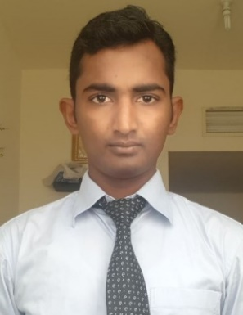

Dear Sir/Madam,
Please find my candidature for your kind consideration for a Linux L1 Administrator, Desktop Engineer, IT Technician, IT Support or any other Information Technology related position within your organization.
I have over three years plus of experience in the IT field Along with my MCSA & Desktop Engineering certifications. Whilst I look forward to your review and consideration, I am also open to any queries that might arise with regards to my candidature and would be honored to be personally available at your earliest convenience.
I am hoping for a positive response from you at the earliest.
Thanking you,
Sincerely,

Sultan Shaikh

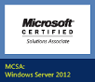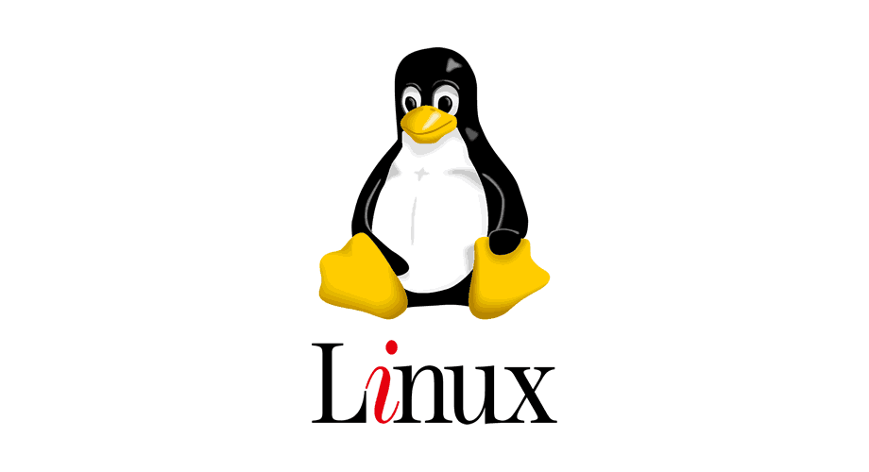

Career Objective: I have over four years plus of experience Working as DCO Support Engineer/Linux System Administrator (L1).

PROFILE
- Installation of RHEL 5, 6 & 7 also Centos 5, 6 & 7, Ubuntu etc.
- Ability to manage all aspects of Help Desk, LAN, Server and Wireless Network.
- Ability to handle Annual Maintenance Contract for multiple Customer Sites.
- Extend regular Maintenance & Technical support to the external Customers and End users on site.
- Self-motivated and team oriented; an effective team player.
- Ability in handling/configuration of DHCP, DNS and Active Directory.
- Hands on experience in OS, Desktop Applications, Windows Server Installation, Configuration and Troubleshooting.
- Working knowledge of Mobile devices and different mobile OS platform.
- Expertise in installation and configuration of servers, desktops and Laptops. Users & group policy management.
- Installation and configuration of CCTV

EDUCATION& CERTIFICATIONS
- DESKTOP ENGINEERING Certified (2014) from CMS institute, Mumbai, India.
- MCSA Windows Server 2012 Certified.
- MCP Win 8.1 Certified.
- MCSA Windows Server 2012 Course attended (2014) from CMS, Mumbai India.
- MCP Win 8.1 Course attended (2014) from CMS, Mumbai India.
- Bachelors Of Commerce from Mumbai University (UAE attested)

TECHNICAL SKILLS
- APPLICATON (S), ANTIVIRUS, TOOL(S) AND UTILITIES:
Installation, Configuration and Troubleshooting in MS Office Applications, Desktops, laptops, network printers, Scanner, Peripherals, Mobile devices and Wireless Network devices.

- SERVER & DESKTOP OPERATING SYSTEM (S):
RHEL, CentOS, Ubuntu, Windows XP, VISTA , Windows 7, Windows 8, Windows 8.1, Windows 10, Windows server 2008 and Windows 2012 (Standard and Enterprise Edition) Installation & Troubleshooting.

- LAN:
Troubleshooting & Maintenance in LAN. Implementation of Windows based Network, Server & Client Networking and Troubleshooting of Internet related problems.

PROFFESSIONAL EXPERIENCE
Total Experience of 4+ years in IT Field

2] Fidelis Corporate Solutions Pvt. Ltd
[JANUARY 2020 – CURRENTLY WORKING]

Project: IDBI BANK

Responsibilities & Experience: Linux L1 Admin

- Installation of RHEL 5, 6 & 7 also Centos 5, 6 & 7, Ubuntu etc.
- Knowledge of Linux commands essential for System monitoring and maintenance.
- Installation of packages & resolving dependencies through RPM / Source code.
- Good Knowledge of User administration
- Adding / Deleting user / group, /setting policies.
- Knowledge of FSTAB / FDISK.
- Configuring / Creating LUN.
- Creating File system using xfs, mkfs, mkfs.ext3, and mkfs.ext4, etc.
- Installing & Configuring SSH Password less login / RSA server.
- System Maintenance using Single user mode, su login.
- Package Installing with Yum, Rpm.
- Configure & Manage NFS server
- Configuring Samba in linux.
- Configure NIC Bonding in linux.
- Creating File System, Partitions using fdisk and LVM
- Configuring Logical volume manager (LVM).
- Installation of Linux OS, Configuration and Troubleshooting.
- Taking daily, weekly & monthly backup.
- Monitoring disk space utilization, load, CPU utilization and memory utilization on Linux servers on daily basis.
- Preparing and maintaining Daily server report containing ‘df’ output of all servers, daily backup status, backup completion status, details about ‘rm’ command used on the server, active users list on the server, logins and bad logins made on the server

2] SYSNET GLOBAL TECHNOLOGY
[JUNE 2018 – DECEMBER 2019]

Project: Reliance Jio Infocom LTD

Responsibilities & Experience: Desktop Support Engineer
- Receive and record technical support calls from end users by using HP Helpdesk tool (HP Service Management)
- Attend and support end users queries on a daily basis.
- Perform daily checks on IT systems.
- Managing IT stock
- Configuring and supporting Microsoft outlook 2010/2013/2016.
- Setup and maintained corporate virus scanning software (Symantec Antivirus)
- Install, upgrade, support and troubleshoot Operating System and any other desktop applications.
- Installation, Configuration and Troubleshooting of HP Desktops & Laptops.
- First point of contact for all IT services provided by IT Department. Prioritize all tickets ensuring all queries resolved within defined Service Level Agreements and monitor SLA breached tickets.

3] Master Technologies LLC DUBAI
[September 2016 – April 2018]

Responsibilities & Experience: Desktop Engineer
- Hands on experience in installing, configuration and troubleshooting Malware bytes, Office 365, CCTV systems, Door access and attendance systems.
- Perform remedial repairs on computers, laptops, printers and any other authorized peripheral equipment Customize desktop hardware to meet user specifications and site standard.
- Install, upgrade, support and troubleshoot Operating System and any other desktop applications [example: outlook], printers, computer hardware and any other authorized peripheral equipment.

4] Core IT Solution
[April 2015 – September 2015]

Project: Aditya Birla Retail Limited

Responsibilities & Experience: Sr. Desktop Engineer
- Receive and record technical support calls from end users by using Helpdesk tool (BMC- Remedy)
- Attend and support end users queries on a daily basis.
- Perform daily checks on IT systems.
- Configuring and supporting Microsoft outlook 2003/2007/2010
- Setup and maintained corporate virus scanning software
- Acted as the first point of contact for all IT services provided by IT Department. Prioritize all tickets ensuring all queries resolved within defined Service Level Agreements and monitor SLA breached tickets.
Installation of Printer (HP & Cannon).

5] MIMAS BEYOND IT
[February 2013 – April 2015]

Responsibilities & Experience: Desktop Engineer
- Installation, Configuration and Troubleshooting of DELL& HP Desktops, Laptops and Servers Applications.
- Handling Annual Maintenance Contract for multiple Customer Sites.
- Analyze, resolve and log details of technical errors occurring with the systems and hardware and Managing Incident records.
- Installation & Configuration of software packages in Computer.
- Installation & Updating of antivirus software, virus removal tools & security patches.
- Troubleshooting and resolving user’s system & network related problems.
- Perform daily checks on IT systems
- Setup and maintained corporate virus scanning software
.

Personal Details

FULL NAME : SHAIKH SULTAN NOORUDDIN

SEX : MALE

DATE OF BIRTH : 2nd March 1990

NATIONALITY : INDIAN

MARITAL STATUS : MARRIED

PLACE OF BIRTH : MUMBAI

LANGUAGE KNOWN: ENGLISH and HINDI (Fluent in Reading and Writing)
AVAILABILITYTO JOIN: IMMIDITLY

CONTACT NO. : +91 90 82 290 890

EMAIL : shksultan404@gmail.com

